1Project Report for Web Design & Development

Contents

Introduction 1

Installation/Usage 2

Design Decisions Made 4

Colours, Text and Fonts 4

Breakpoints 5

Navigation 6

Performance 6

SEO 7

Accessibility 7

Wireframes 8

Reflection on your work 8

# Introduction

For my Web Design and development project I decided to create a website from scratch based on my love for video games as I believe it would spark more creative interest and motivation designing for a product I enjoy using as well as having familiarity with.

My Website itself is called “Piranha Plant Games” and its focus is the selling and delivering video games to customers.

# Installation/Usage

**All Pages**

Responsive Bootstrap Navbar with links to other pages.

Responsive Rows and columns for Desktop, tablet and mobile use.

Footer, with work social media buttons that link to respective website.

Return to top button that sends user to the top of the page.

Login/Logout will log user in or out using local storage.

**Home**

The following games can be added to the cart:

* Call of Duty: Modern Warfare
* Death Stranding
* The Outer Worlds

Carousel should automatically change images but can be clicked to go through slides.

Any green “Add to cart” button will increase checkout counter.

More Info buttons will display collapsible text about the game selected.

Embedded YouTube Videos.

Find out more button will link user to external website.

Working countdown clock to game release date (JavaScript).

**Shop**

The following games can be added to the cart:

* Call of Duty: Modern Warfare
* Death Stranding
* The Outer Worlds

Any green “Add to cart” button will increase checkout counter.

More Info buttons will display collapsible text about the game selected.

Embedded YouTube Videos.

Find out more button will link user to external website.

Working countdown clock to game release date (JavaScript).

**About Us**

**Contact Us**

Embedded Google Maps.

Form to enter comments.

**Login**

Login form with following require details.

* Email: [Flan97@mail.com](mailto:Flan97@mail.com)
* Password: password1

Not registered link takes you to Registration page.

**Registration**

Form with use of required fields and regex.

Terms and Conditions button collapsible text.

**User Details**

Form with placeholders based on local storage information.

Submit button will update user storage and thus change checkout placeholders.

**Cart/Checkout**

Qty Represents qty of selected items in cart (local storage).

Cost under each game represents cost*qty (local storage).

Total <h2> represents total cost of cart (local storage).

Checkout details placeholder based of local storage or if details updated.

Required Details needed to place order.

* Card number: 1234 5678 9102 3456
* CVC: 123

Submit will empty basket, qty, cost in local storage and send user to shop page.

All element required in the brief should be working and nothing has been left out.

# Design Decisions Made

## Colours, Text and Fonts

**Colour**

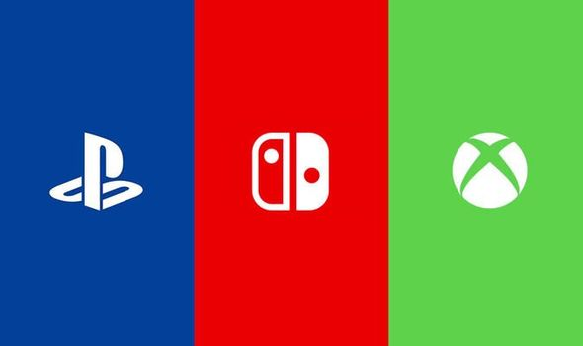To begin, I set a requirement that the colour pallet could not have any red, green, or blue as the primary colour. The reason for this was that my website sold video games which would have to be sold on either the PS4, Xbox One or Nintendo Switch platforms, which all use those as their company colours. (See image right).

After testing out basic colours for my website with no luck, I decided to do some research online for potential colour pallets that stood out to me. After going through some websites, I choice this colour scheme (see image below). I liked the bold neon style which I believe fit into the video game theme I wanted for my website, but it also used purple as one of its primary colours.

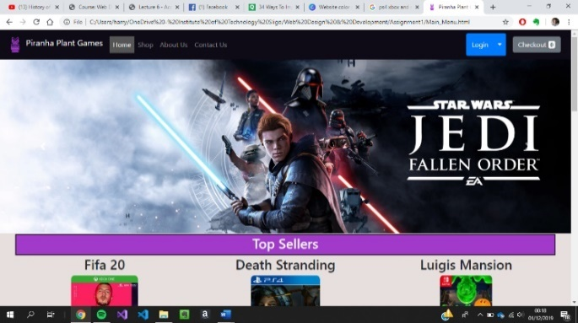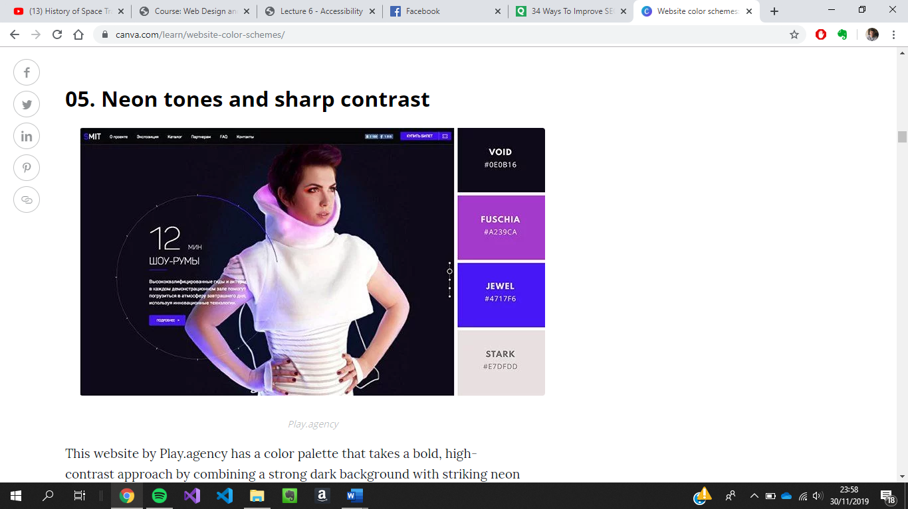I used ‘void’ black for my nav and footer to help them contrast with ‘stark’ white of the main body of the page. For my logo and headers, I used ‘Fuschia’ purple to help them contrast with the video game platform colours mentioned previously.

**Fonts & Text**

For my website I decided to stick to the ‘Helvica Neue’ used in bootstrap. The reason for this was because I did not like any of the over fonts I tested out on the page as they made the pages look either too unprofessional or too boring for a video game company. I found that bootstraps ‘Helvica Neue’ looked professional while still engaging and readable. The only other changes I made to the text was to the colours of heading to contrast with the background of the page.

I didn’t use any text effects as I want the visuals of my product images not to compete with my text. Because of this I keep the text short and basic with no extra stylings or effects aside from changes to the colour pallet.

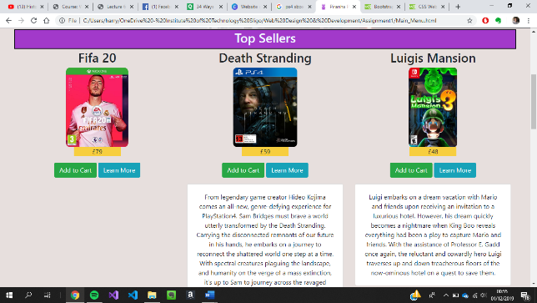

## Breakpoints

For all pages I used the bootstrap grid style to separate the content of my pages. With this I then used different col sizes to allow my rows to adapt to each device (see below images).

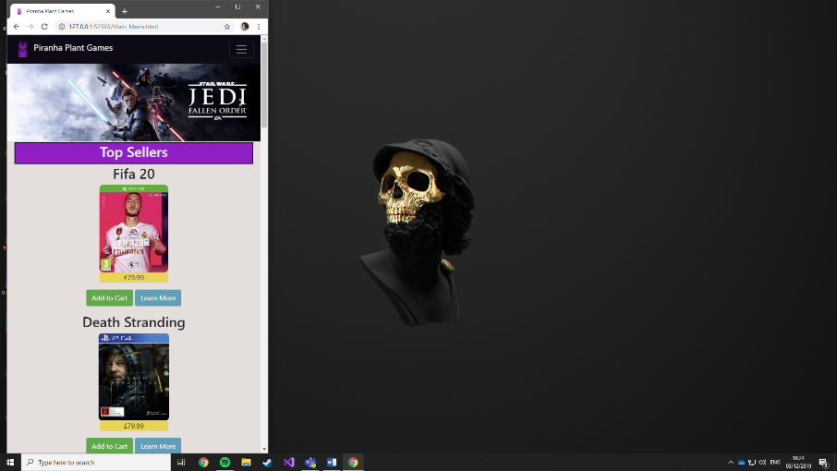**Small (col-sm)**

When the page is set to a small window for mobile devices, the items in each col display one once per row to ensure that the information can still be large enough for users on mobile to understand. I also decided to use bootstrap’s navbar as it will automatically set the navigation links to a burger menu to save space and make it easier for mobile users to navigate between pages.

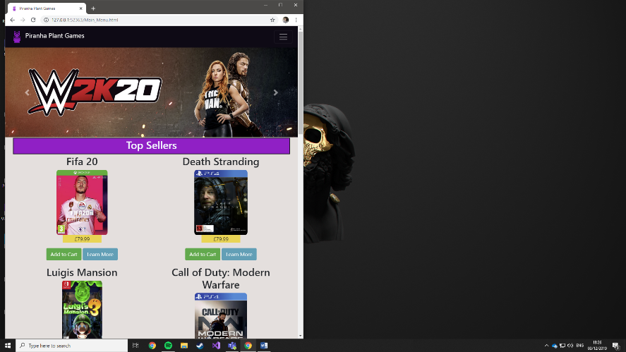**Medium (col-md)**

When the page reaches a medium size for tablets and larger mobile use, the columns allow for two items per row to take up the space on the screen to make use of the larger available screen space without overwhelming the user with too many items as seen in the desktop usage. Like in the smaller size section, the bootstrap navigation bar also uses a burger menu help the user more easily navigation the pages.

**Large (col-lg)**

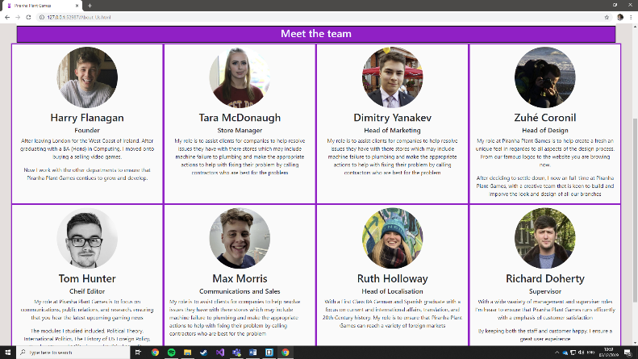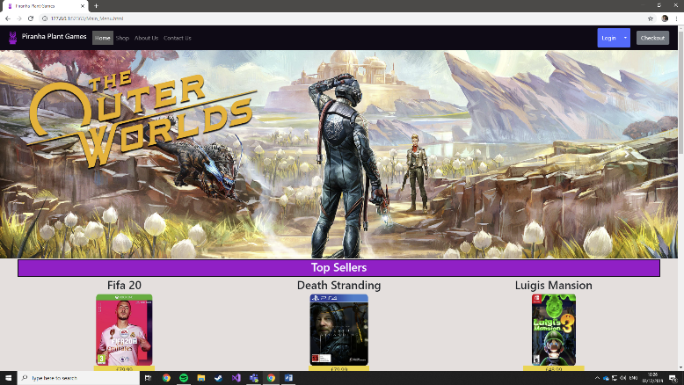On a full-size desktop, I allow for 3 items per row on the home and shopping pages. Although I could arguably use more, I like the minimalist style and it allows the user not to become overwhelmed with the number of items on the screen. It also gives each item more of its own space to not have to compete with the other items on the page. Despite this I do use 4 columns per row on my About Us page as I believe the page filled lets the user believe that there is a large number of staff members working in the company. (See images below).

## Navigation

**Navigation Bar**

The nav bar is positioned at the very top of the page and uses buttons for each of the pages. It uses a dark style that fits in with the chosen colour scheme for my website, and to contrast with the lighter background of the main body of the page. Starting from the left, I used the website logo followed by the name of the website. Next, I have links to the rest of the pages within the website, with the current page the user is on being highlighted as ‘active’. On the far right of the nav, I have separated my login/logout button, and checkout button to signal to the user that they have a different purpose to the other links to other pages.

Using JavaScript, I managed to get the login/logout button’s html to change depending on a local storage value. I also used a drop-down arrow that allows the user to access the user details page. The checkout button will send the user to the cart page and will display the number of items that are in the cart.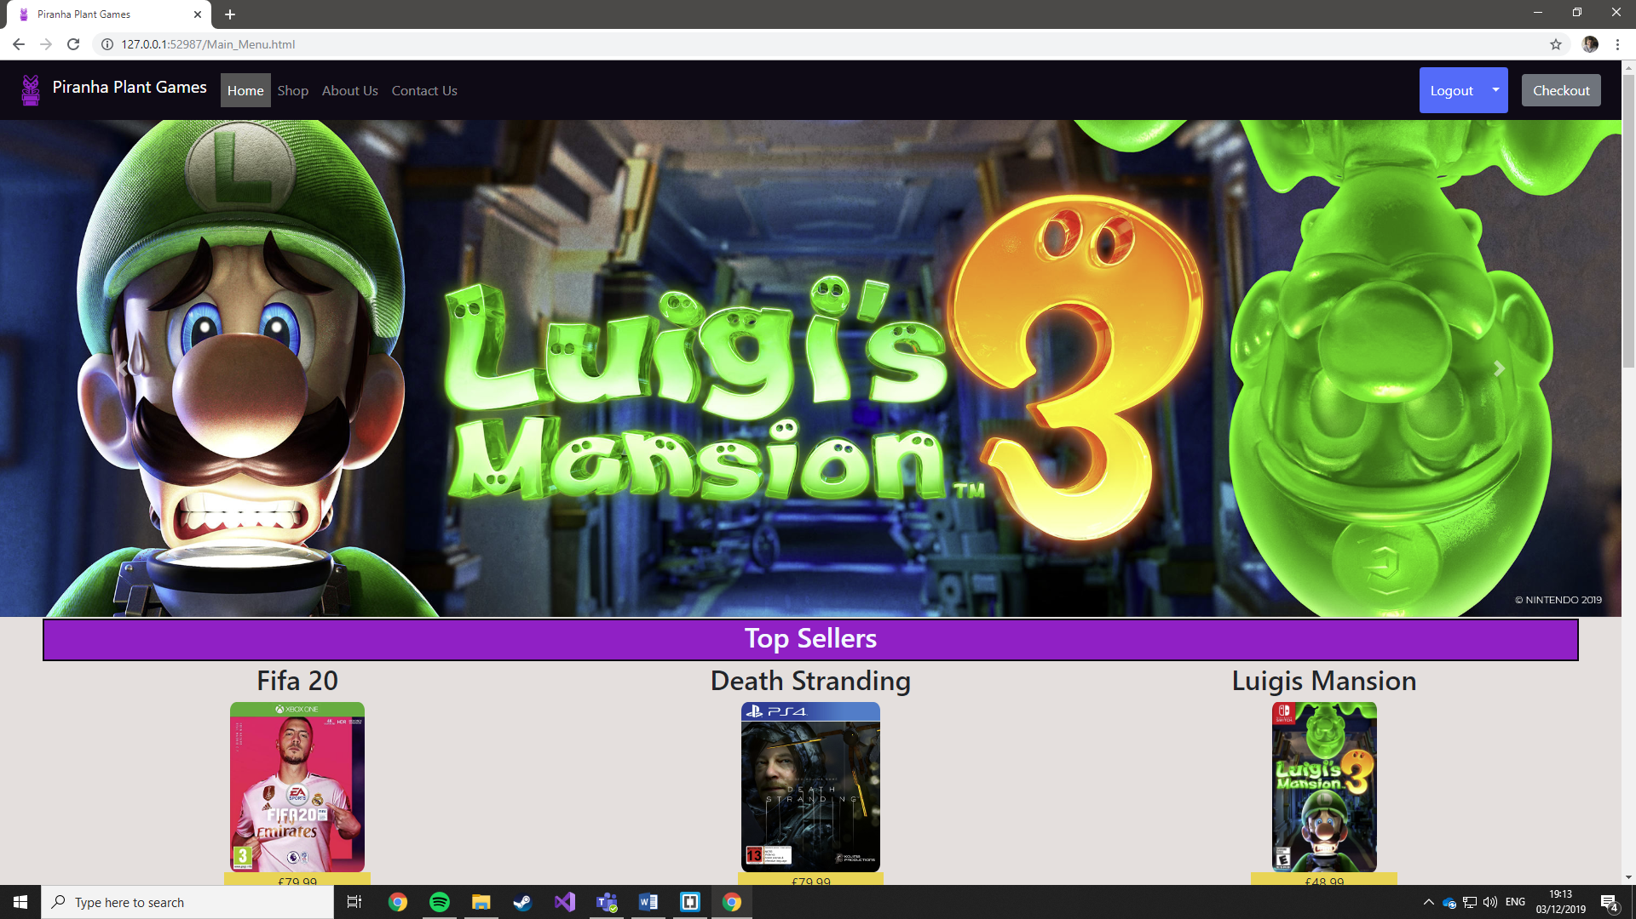

**Footer**

The footer of the page is fixed at the bottom of the page. Like the navigation bar it uses the same darker theme to contrast with the main body. It also uses the same logo at the far left. Next, the footer contains social media buttons with act as external links to their social media website. On the far right I have used a button that will return the user to the top of the page, allowing for more accessibility for users on mobile devices. Finally, I have extra small copywrite text as it is a standard for most websites, which I wanted to recreate.

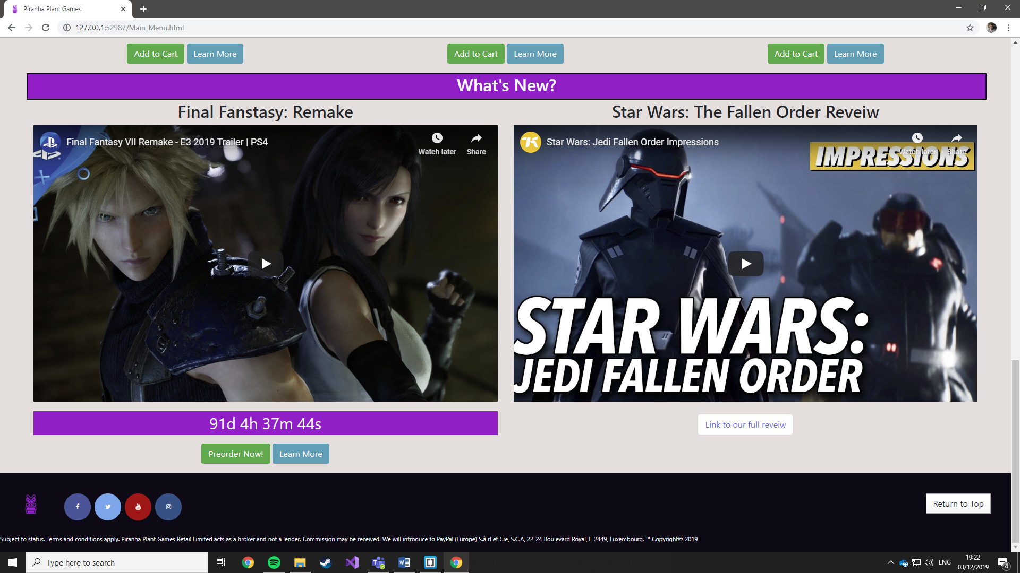

# Performance

I ensured that I placed my JavaScript links at the bottom of my html page before the end of the body and kept my CSS stylings at the top. The reason for this is so when the page loads it won’t have to wait for larger JavaScript files to be loaded to create the illusion the page as already fully loaded. Another way I ensure the quality of my site was to ensure that the folder that contained all of the content of my website was not contained within my C: Drive (Or any other folder) so the Brower did not have to look through all the contents of every other irrelevant folder, thus slowing down the loading time of the page.

If I was to further improve the performance of my website, I would take more care to ensure I only use images with the appropriate size that I am using them for, or to edit them in photoshop to reduce the size. This means that the page doesn’t need to waste time resizing the images as the page loads.

# SEO

To being with I ensured that all my pages include a common title. I also included description meta data, descripting the company and what we do, thus and adverting the website. Next, I included keywords meta data with content that would feature on my page and is also relevant to selling video games. Finally, I included an author, meta data tag.

Within the content of my html pages, I ensured that all images had alt tags, and used headers to break up the page.

# Accessibility

Visually I made sure that my website used a consistent theme with the colours and styling. This included contrasting colours for the background and foreground making it easier to users to see. I also ensures that I used no flashing imagery or animation effects to overwhelm users.

For the content of my pages I had all the text short and precise, with all the most important content displayed at the top of the page. I then broke up the content of my page using headings with clear titles, so users knew exactly what it was they are looking through. My buttons also were clear and used consistent colour coding depending on their purpose. The text within the buttons were also very short and described exactly what they did. Finally, I included a button within my footer that returned the user to the top of the page.

Finally, for my forms I made sure that all were grouped with labels and legends so users could easily distinguish different parts of the form.

# Wireframes

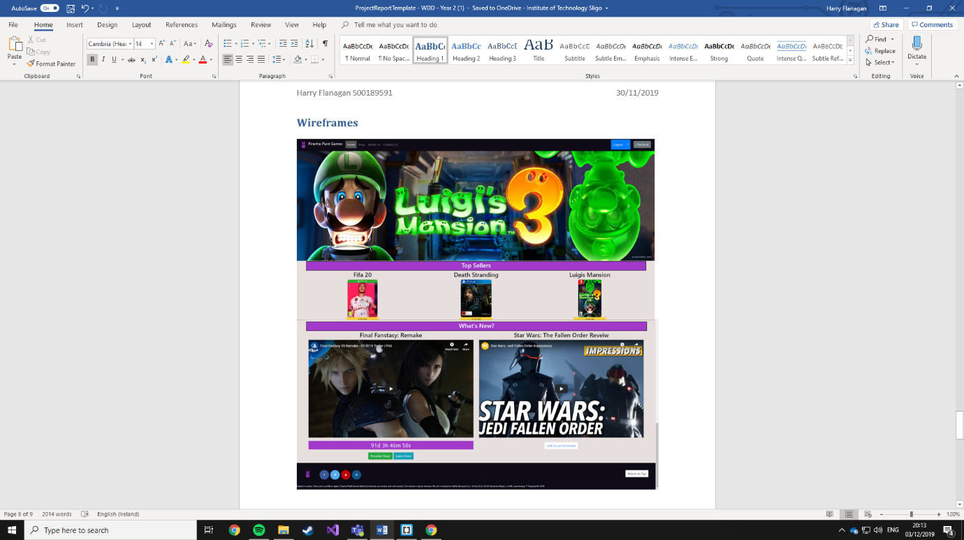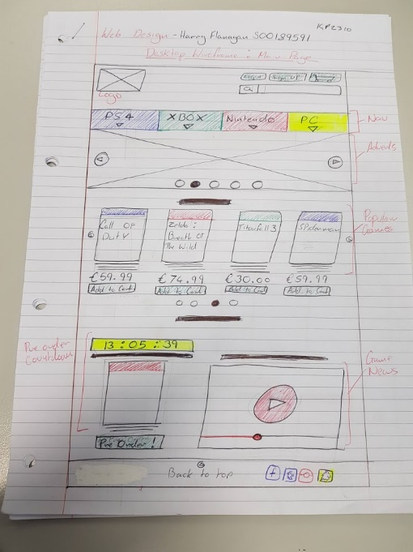

I believe I had successfully used my wireframe as a good guide for my website and a lot of the features have been passed over. Some features did not make it into the final product, such as the search bar, user info displayed in the navigation and having 3 separate pages for each video game platform. The reasons for these not being including in the final website would probably be due to my lack of confidence with the advanced JavaScript features and time constraints with other projects. For the separate pages based on the video game platforms, I soon decided in the development process that it would not be worth the time to create multiple shop pages to display and saturate the small number of items into 3 categories when I could simply create 3 headings and separate the information within the same shop page.

# Reflection on your work

**Describe briefly anything you are particularly happy with.**

I am extremely happy with the styling and constancy of design of my pages as I believe they look much more professional than any other website that I had created in the past. I am also happy with the JavaScript features that I managed to get working after much trial and error. For example, the countdown clock and total pricing and qty in the checkout page.

**Describe briefly anything you tried which did not work.**

I initially had difficulty working with the local storage and needed to research experiment on my own, which was quiet time consuming. Because of this experimentation style to get my qty and total pricing working I needed to use location.reload(true); to refresh the page. However, by doing this I had prevented my checkout displaying the qty in the navigation bar. Because this happened late into the project and my confidence on local Storage JQuery wasn’t that good. I decided it wasn’t worth the risk of breaking the other extra features I took so long to get working.

**Describe briefly what you would do differently another time.**

I would have ensured that I took more time in commenting and format my code neatly as I went a long as it got out of control with the size of all of my pages and I was more concerned about getting the page to work the way I wanted than the correct way of writing code.

I would have also reached out sooner to my lecture if there was a topic I didn’t fully understand. If I didn’t do this a lot of features I did manage to get working would not be in my final project.